**EXP NO 2: CREATE A SIMPLE CLOUD SOFTWARE APPLICATION FOR FLIGHT RESERVATION SYSTEM USING ANY CLOUD SERVICE PROVIDER TO DEMONSTRATE SAAS.**

**DATE:**

**AIM:**

To create a simple cloud software application for flight reservation system using

any cloud service provider to demonstrate saas.

**PROCEDURE:**

**step1:** Go to zoho.com.

**step 2:** Log into the zoho.com.

**step 3:** Select one application step.

**step4:** Enter application name as flight reservation system.

**step 5:** Created new application flight reservation system.

**step 6:** Select one form

**step 7:** The software has been created.

**IMPLEMENTATION:**

1. **All Payments**

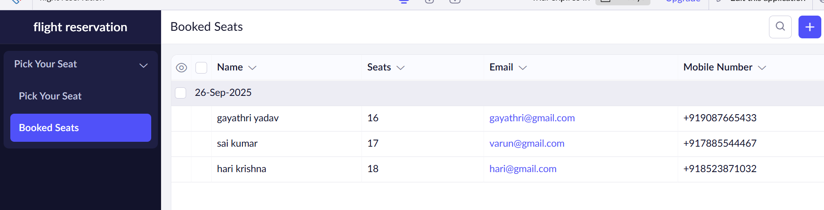

1. **All Flight searches**

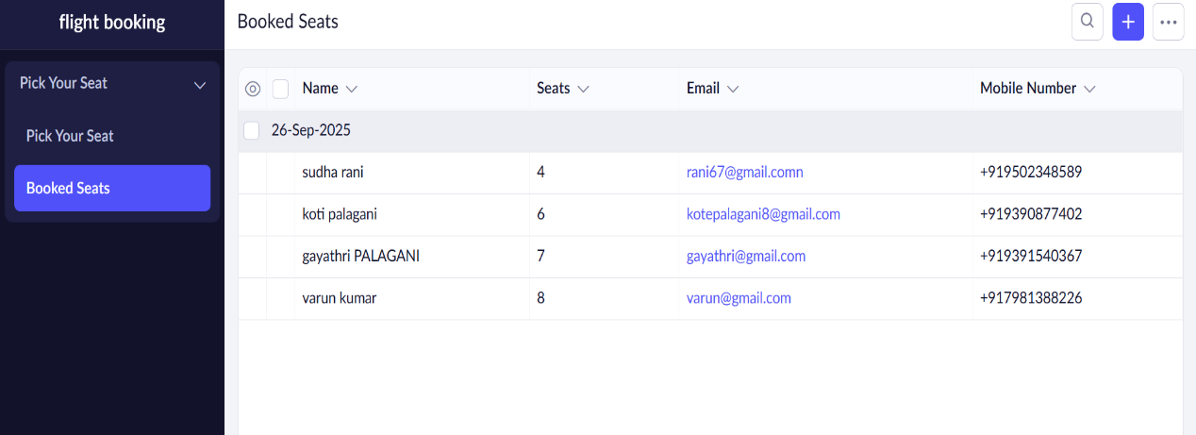

**3 .All Passengers Details**

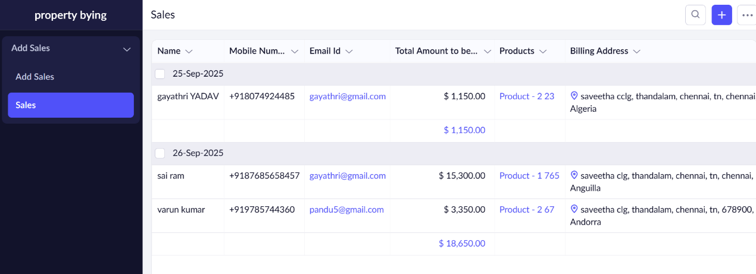

**RESULT:**

Thus, a **F light Reservation**  **System** application was successfully created using **Zoho Creator (Cloud SaaS platform)** with the forms:

* All Flight Searches
* All Passengers Details
* All Payments

This demonstrates **Software as a Service (SaaS)**, where the Flight Reservation System can access the system anytime through the cloud without installing any software.